HACETTEPE UNIVERSITY
Department of Computer Engineering

Fuzzy Modelling
Laboratory

Furkan Simsekli
5th Semester
Turkey

Academic Year 2023/2024

Exercise 3

Write a script to draw the sigmoidal membership functions, which are described by the following mathematical relations:

C1 – red C2 – green C3 – blue
Z1 – line character „*” Z2 – line character „+” Z3 – line character „d”
DS = 0.25 R=[-1, 9]

Draw the membership functions µA(x), µB(x) and µC(x) on one graph in the range of R. Use the following colors µA(x) – C1, µB(x) – C2, µC(x) – C3, a continuous line for each function and line characters Z1, Z2, Z3.

Sign the membership functions in the following way µA(x) – MFA, µB(x) – MFB and µC(x) – MFC. Use a DS discretization step.

Write the equation describing the α-cut of a fuzzy set. Determine the α-cut of the fuzzy sets: α-cut(A) for α=0.3 and α-cut(B) for α=0.6.

Solution

% Sigmoidal membership functions
xa=[-1:0.25:9]
ya=1./(1+exp(-4*(xa-3)))

xb=[-1:0.25:9]
yb=1./(1+exp(-2*(xb-5)))

xc=[-1:0.25:9]
yc=1./(1+exp(-8*(xc-5)))

% plot the curves
plot(xa,ya,'r-*',xb,yb,'g-+',xc,yc,'b-d')
grid on

% axis, line width, font size
set(gca,'fontsize',16)

% add descriptions to the drawn graphs
text(2.2,0.9,'MFA','fontsize',16)
text(6.5,0.9,'MFB','fontsize',16)
text(4,0.9,'MFC','fontsize',16)

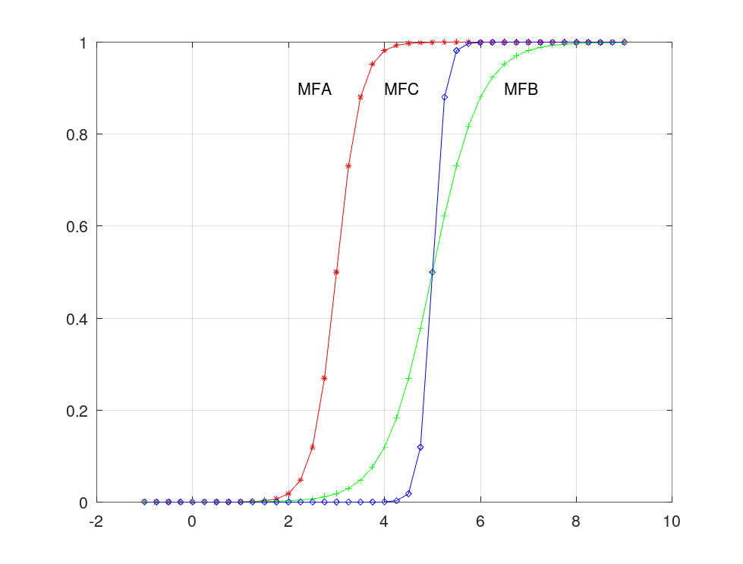
Figure 3.1: The sigmoidal membership functions MFA, MFB and MFC

α-cut(A) for α=0.3
α-cut(A) = {3, 3.25, 3.5, 3.75, 4, 4.25, 4.5, 4.75, 5, 5.25, 5.5, 5.75, 6, 6.25, 6.5, 6.75, 7, 7.25, 7.5, 7.75, 8, 8.25, 8.5, 8.75, 9}

α-cut(B) for α=0.6
α-cut(B) = {5.25, 5.5, 5.75, 6, 6.25, 6.5, 6.75, 7, 7.25, 7.5, 7.75, 8, 8.25, 8.5, 8.75, 9}

% Sigmoidal membership functions
xa=[-1:0.25:9]
ya=1./(1+exp(-4*(xa-3)))

xb=[-1:0.25:9]
yb=1./(1+exp(-2*(xb-5)))

xc=[-1:0.25:9]
yc=1./(1+exp(-8*(xc-5)))

l03=xa*0+0.3
l06=xb*0+0.6

% plot the curves
plot(xa,ya,'r-*',xb,yb,'g-+',xc,yc,'b-d',xa,l03,'m',xb,l06,'c')
grid on

% axis, line width, font size
set(gca,'fontsize',16)

% add descriptions to the drawn graphs
text(2.2,0.9,'MFA','fontsize',16)
text(6.5,0.9,'MFB','fontsize',16)
text(4,0.9,'MFC','fontsize',16)

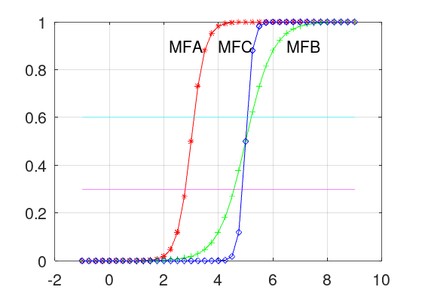

Figure 2.2: The sigmoidal membership functions MFA, MFB and MFC with α-cut lines.

